Creating an event request
Once you have been approved as a community portal user, you will be able to create an event request. If you have questions about filling out the event form, please contact Toni Quinn at 406.771.2268 or events@gfcmsu.edu.

- Navigate to https://events.dudesolutions.com/gfcmsu/site/communitysite
- Click SIGN IN
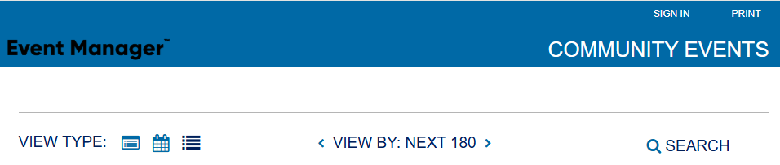

- Enter your email and password and hit SUBMIT. 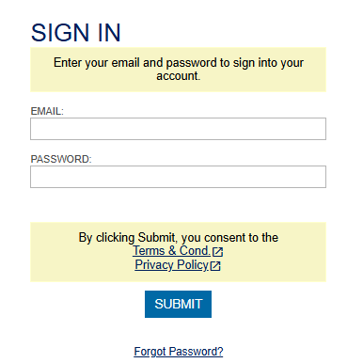
This will take you to the Community Event Request form.
- Click Create an Event.

- Select your Organization. *Note: You will only be able to select Organizations that you have been added to as a member.
- Enter an Event Name.
- Add a Summary if you’d like to add more information; otherwise, re-enter Event Name.
- (Optional), check the box next to Add a Full Description. This allows for a longer description of the event.
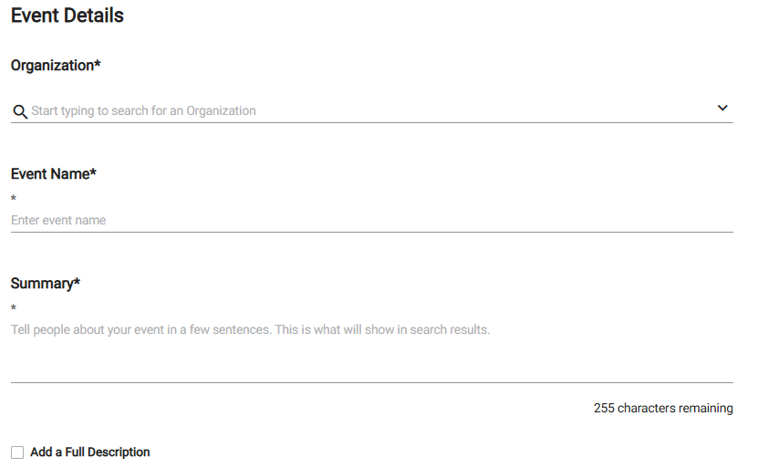

- In the Choose By drop down menu, select Location & Time.
- Select the desired Location from the drop down menu
OR
Click Location Search in the Locations You've Selected panel.
  - check the box next to the requested location.
  - Click Save.
Under Location Setup Notes, enter any setup notes such as the number of chairs and tables (for Heritage Hall), requested IT support, etc.
- Enter the number of attendees.
- (Optional) Check the box next to any desired Location Features, such as Fixed Projector or Presentation Computer and add a note if desired. *Note: If a feature is grayed out, it is fixed to the location and cannot be removed.
- Under Check Availability, click Choose Dates
- Choose the date of your event.
- Select the start time of your event by clicking the time on the calendar. Drag the time slot to the end time of your event.. *Note: Any times that are unavailable will show with a block marked Unavailable. This means the time has been booked with another event.

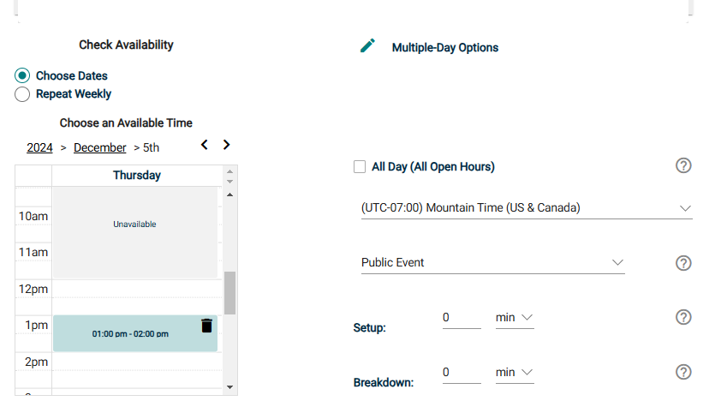

- Only follow this step if your event is more than one day: If your event will repeat, click on the pencil icon next to Multiple-Day Options. *Note: This option will only appear after you have selected a time on the calendar.
    - Choose between Consecutive Dates and Non-Consecutive Dates.
    - If you chose Consecutive Dates, choose how often the event repeats, and when the event series ends. (Default is 5 days) After choosing the event pattern, the Events in this Series will populate. Any necessary adjustments can be made here before saving, including the event name, date, or time of an individual event.
    - If you chose Non-Consecutive Dates, click on the dates on the calendar you need for your event series. Then make any necessary adjustments to date, time, or event name for the individual events.
    - Some events may be marked as a Conflict. If this message appears, please contact Event Services.
    - Click Save.

Multiple Days – Consecutive Dates
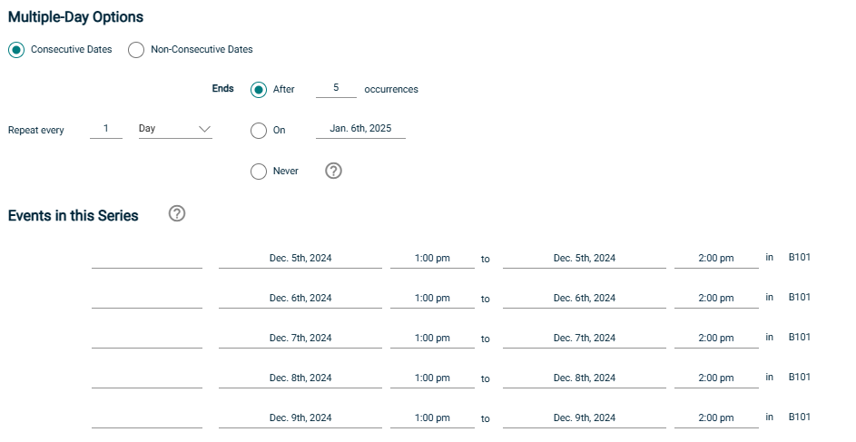

Multiple Days - Non-Consecutive Dates
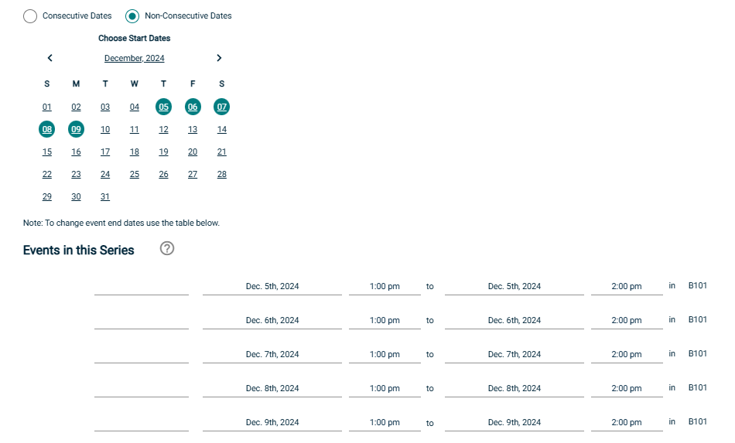

- Do not check All Day option
- Choose Public Event
- Under Category, Select Community Event
- Keywords: Leave Blank
- Tasks: Leave blank
- Contact Information: Enter your full name, phone number, and email address
- Billing Address: If you want it billed to a different address than your organization, choose Custom Address. Otherwise, check Organization’s Address.
- Answer the questions under Additional Information
- After reading the Terms & Conditions, click “I agree’
- Click Submit

This will submit the event request to Event Services, where it will be reviewed and approved. We may call or email you to discuss your event further before approval.

